**Nama : Qirani Rifa Annisa  
NIM : 18090057  
Kelas : 5D**

1. **Source Code**ModelUser.php -> application/modelModelBuku.php ->application/model
2. **Database**  
   a. user  
   b. role  
   c. kategori  
   d. buku
3. **Capture Hasil**

**user**

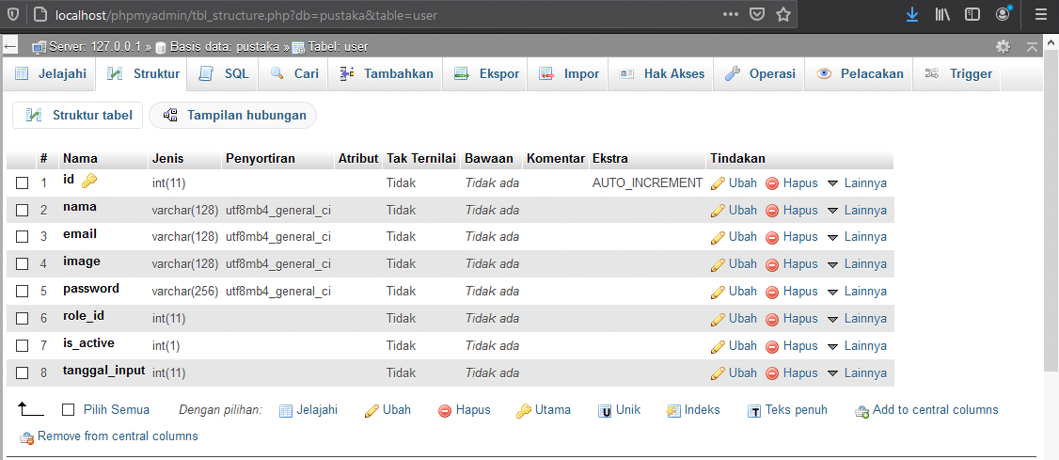

**role**

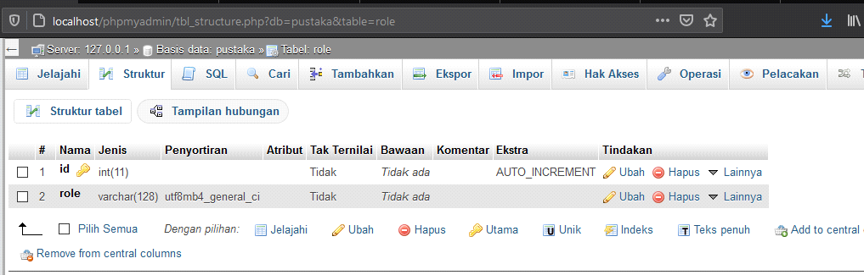

**kategori**

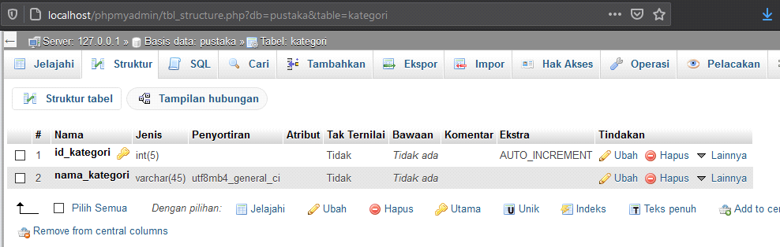

**buku**

